NAME: AKSHAY S RATHOD

SQL PROJECT

PROJECT TITLE: RAILWAY MANAGEMENT SYSTEM

Overview: It is a Railway Management system in which a user can book tickets, cancel reservations, check fares etc.

1. Book a Ticket: Users can book a ticket
2. Cancel a Booking: Users can cancel a booked ticket
3. Check Fares: Users can check fares before booking
4. Show my Bookings: User can check their bookings
5. Show Available Trains: Users can see the available trains

DATABASE DESIGN

DATABASE:TEST

TABLES:

.availabletrains

.bookrailticket

.cancelticket

.checkfair

.railsystem

.showmybookings

.users

CREATING TABLES:

RAILSYSTEM

CHECKFAIR

CANCELTICKET:

SHOWMYBOOKINGS:

AVAILABLETRAINS:

CANCELTICKET:

DATA DEFINITION LANGUAGE (DDL):

A)CREATING TABLES

1.AVAILABLETRAINS

2.BOOKRAILTICKET

3.CANCELTICKET

4.CHECKFAIR

5.SHOWMYBOOKINGS

6.RAILSYSTEM

B) ALTER TABLE

.ALTER TABLE ADD COLUMN

.ALTER TABLE MODIFY COLUMN

RENAME TABLE



DATA MANIPULATION LANGUAGE(DML)

.INSERT INTO TABLE



UPDATE INTO TABLE

DELETE INTO TABLE

DATA QUERY LANGUAGE (DQL)

.ORDERBY QUERY DESC

.ORDERBY QUERY ASC

LIMIT QUERY

SELECT QUERY WITH SPECIFIC COLUMN

DISTINCT QUERY

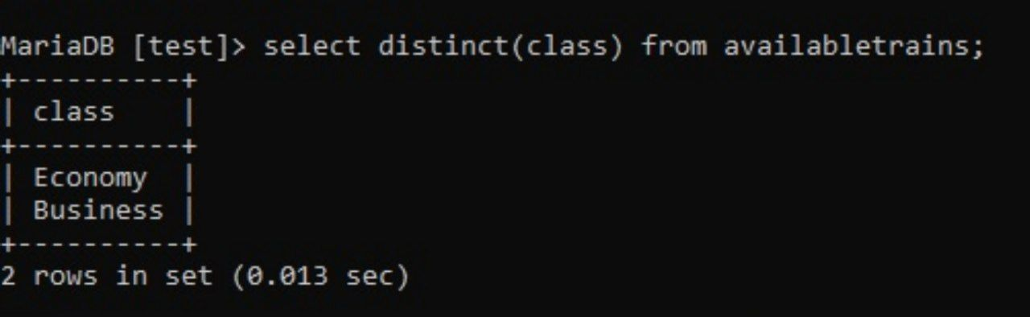

USING WHERE CLAUSE

USING LOGICAL OPERATOR

\*AND OPERATOR

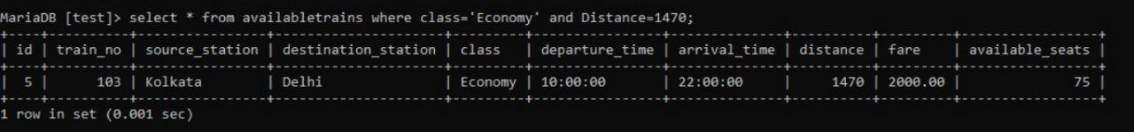

\*OR OPERATOR

\*BETWEEN CLAUSE

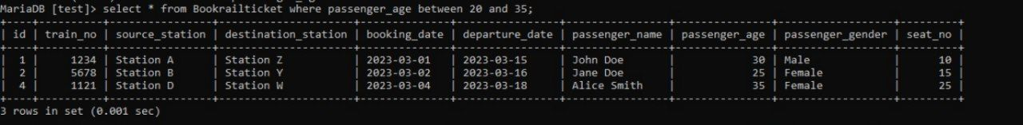

\*IN CLAUSE

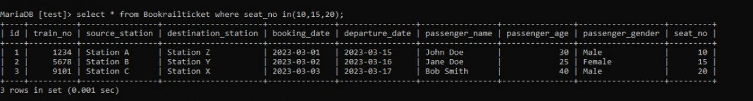

AGGREGATE FUNCTION

-COUNT FUNCTION

-AVERAGE FUNCTION

-SUM FUNCTION

GROUP BY CLAUSE

LIKE OPERATOR

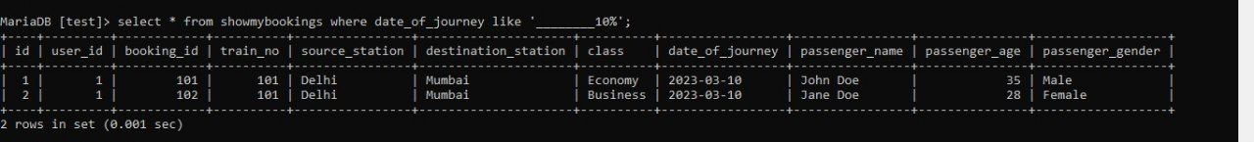

UNION

JOINS

SUBQUERY

VIEWS

